**ASSIGNMENT 1**

1. Power BI front page

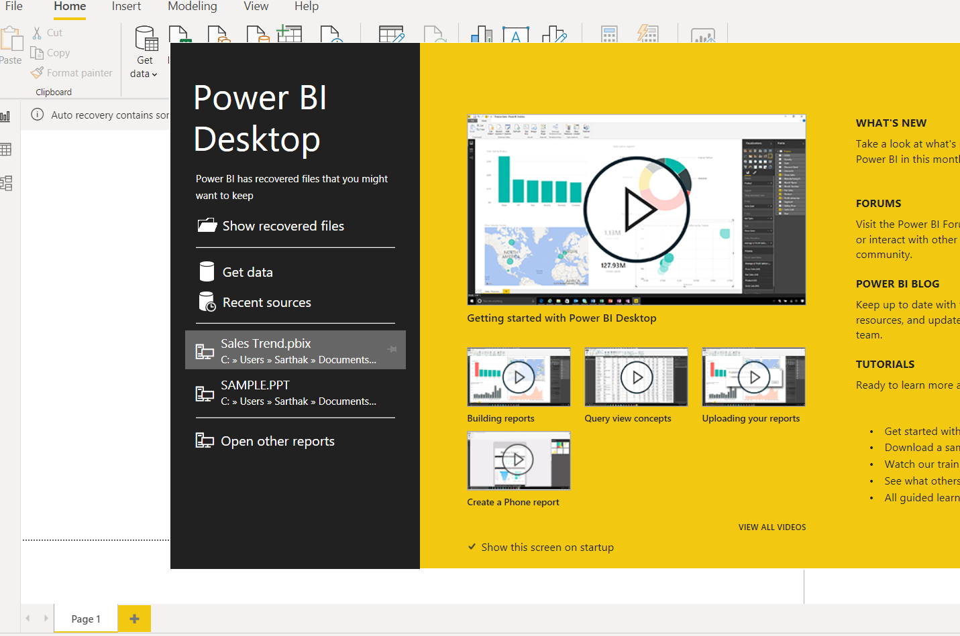

1. Report View

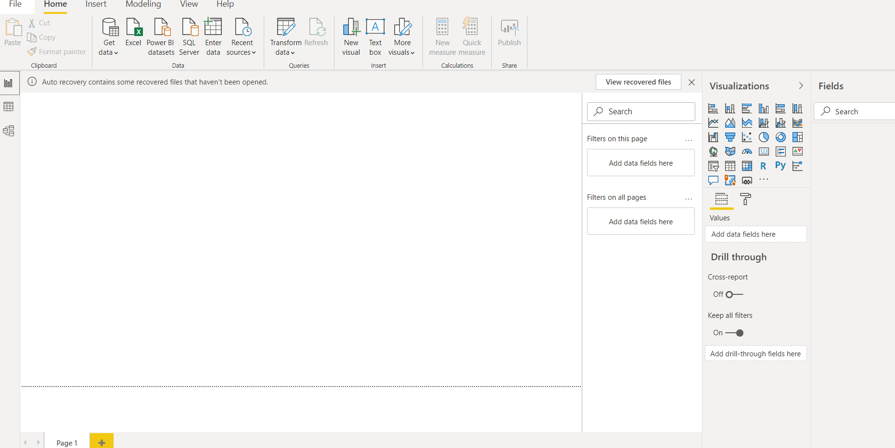

1. Data View

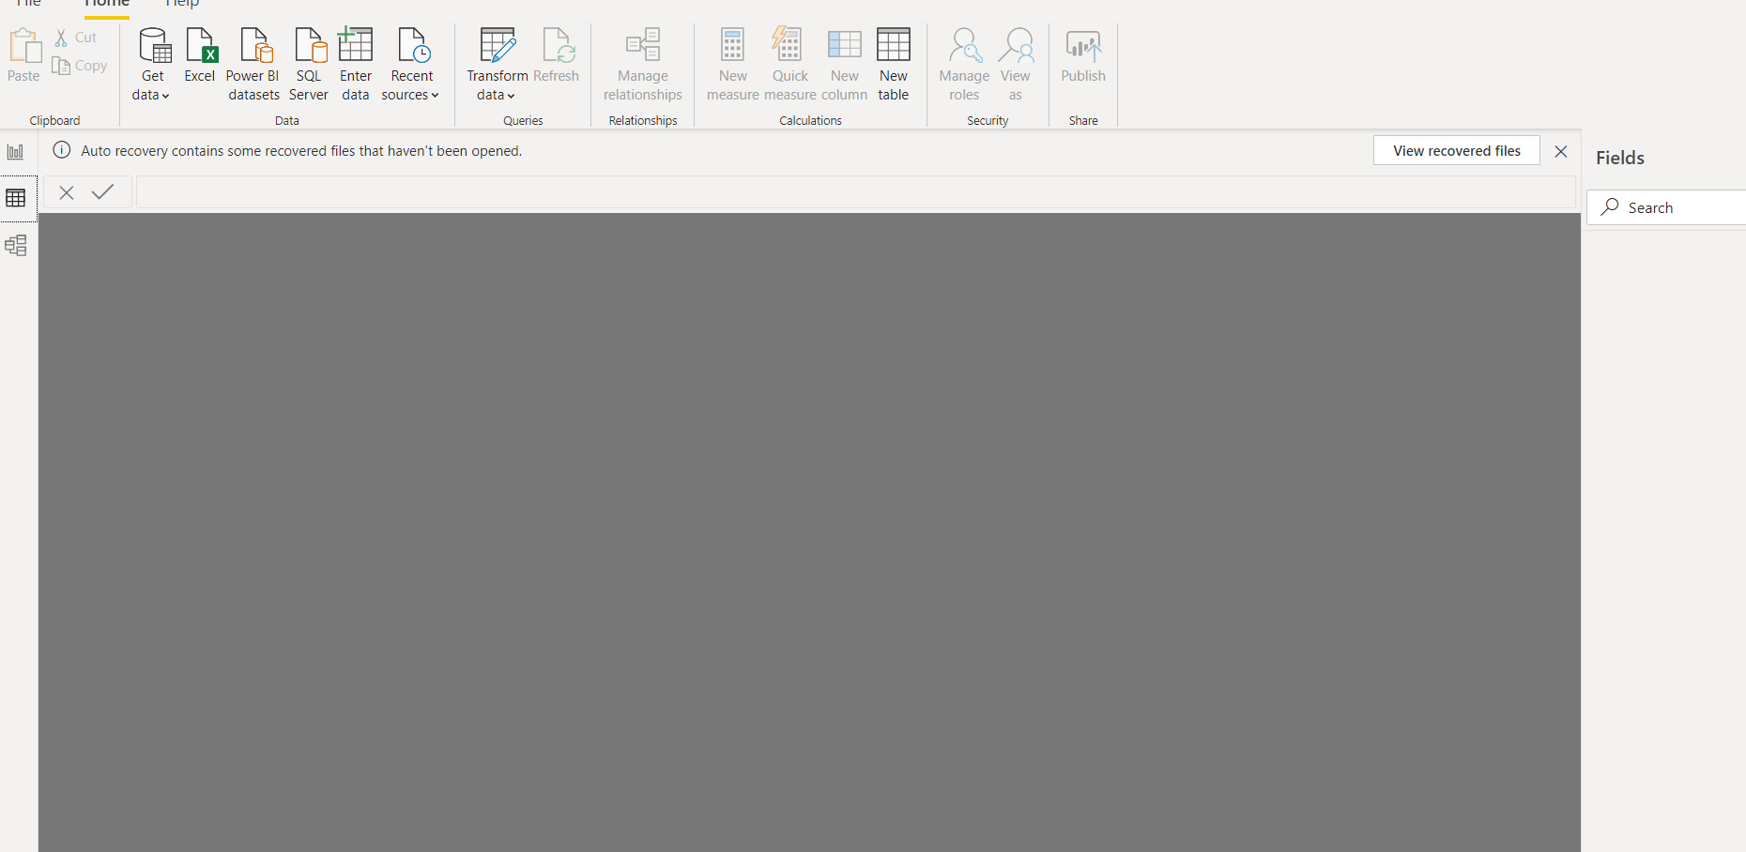

1. Model View

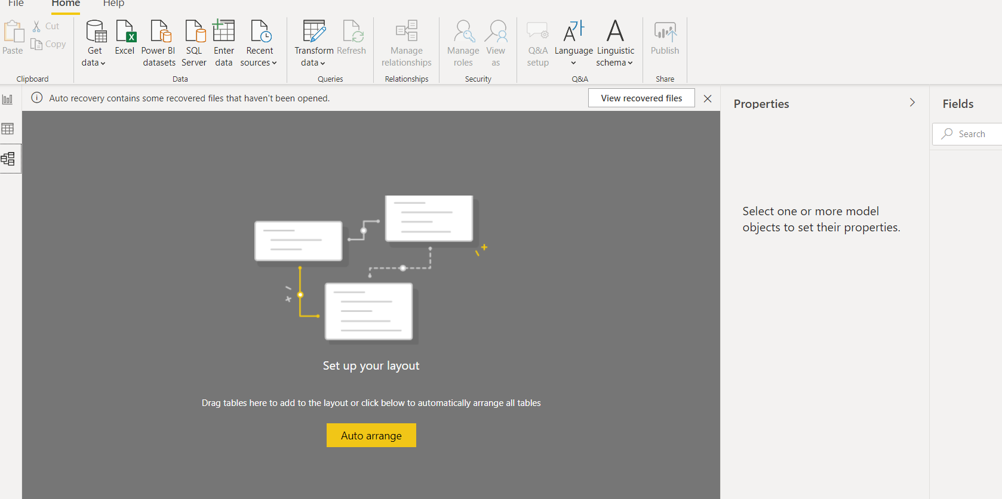

1. Power Query Editor

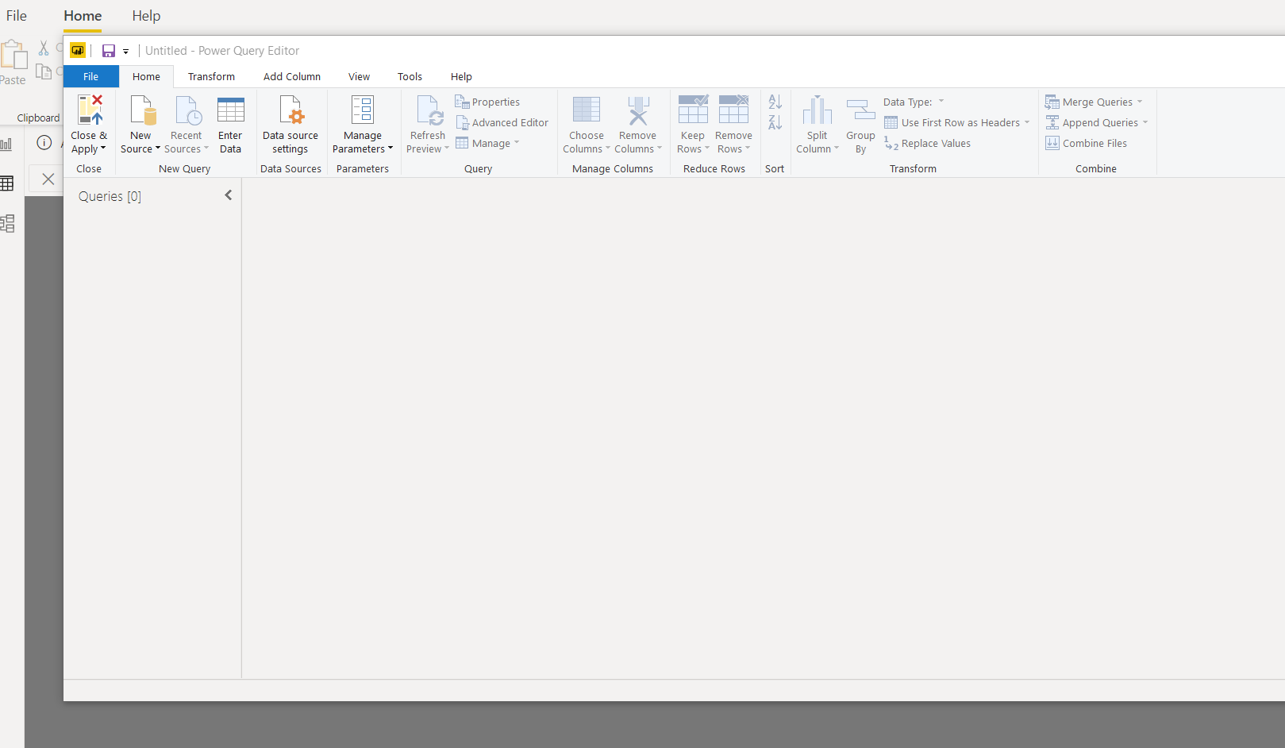

1. Power BI desktop is free for individual users

Power BI Pro is $9.99 per user per month

Power BI Premium plan starts at $4,995 a month per dedicated cloud compute and storage resource.